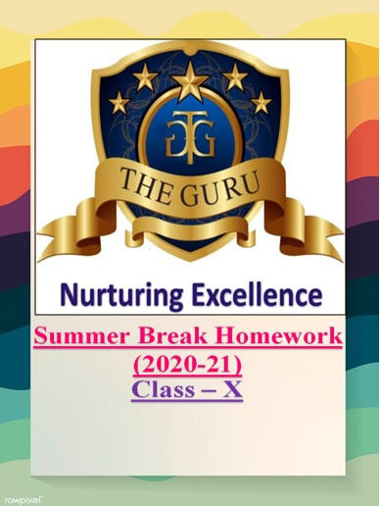
1. MATHEMATICS: -
- Revise all the chapters that have been covered till now from your reference books. Solve them in your fair notebooks which are used for the work from the reference book.
- Case Study/ try to understand and work forward in Chapter 8 and Chapter 9, i.e. Introduction to Trigonometry and Applications of Trigonometry respectively. This work shall be done in your fair notebooks of NCERT.
2. CHEMISTRY: -
- Prepare a project report on Covid 19.
- Prepare 25 questions from each chapter (Acids, Bases and Salts; and Metals and non- metals.) from NCERT textbooks.
3. BIOLOGY: -
- Complete the Questions- Answers from NCERT of chapters 1, 2 and 3 in your fair notebooks and learn them by heart.
- Complete the exercises given at the end of each chapter in book itself (in pencil).
4. ENGLISH: -
a) On an A4 size sheet write an article onthe following: -
- Coping with stress during lock down
- Role of youth in making new India
b)Read an English newspaper daily and pick any social issue of your choice going on in our country. Write a letter to the editor of any major circulation, discussing the issue and suggesting possible solutions for it.
c) Create dialogues between two friends about the present pandemic scenario.
d) Write an analytical paragraph on any bar graph of your choice. (paste or draw the graph also)
e) Write an analytical report in any pie 📈chart of your choice. (paste or draw the chart)
(Note:for questions d) and e) do not select actual figures in your written description as your language will be tested and not mathematics.Do all the written work in literature 1 copy.)
f)Prepare any 1 chapter of your choice that has been covered till now for “I-speak”. It will be assessed after your vacation.
g) Read all the uncovered chapters from both the literature books.
h) Learn the written work from your notebooks.
5. COMPUTER APPLICATIONS: -
- Make a Report file for HTML and Python. This project file constitutes 20 marks of Board Practical exams. Index and acknowledgment are to be included properly. It should be hand-written.
- Write HTML coding for given outputs: -
i)
ii)
iii)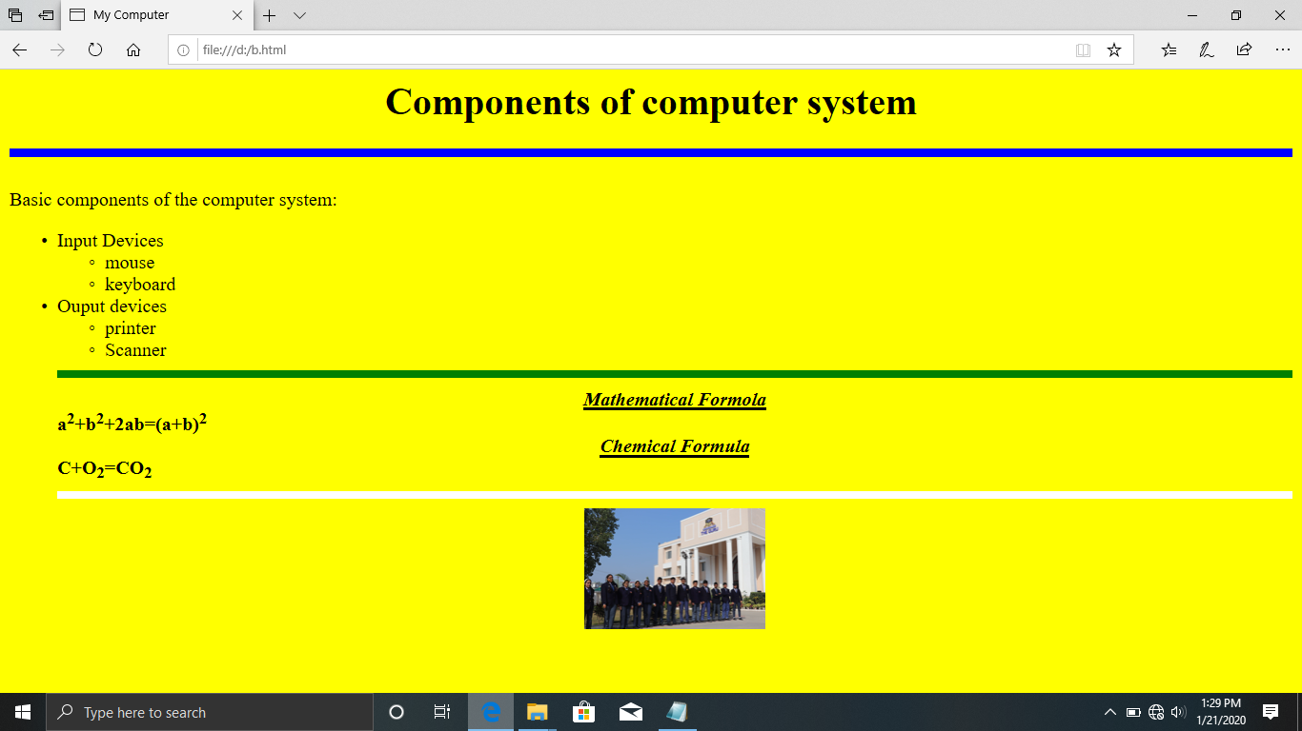

- Write a program to check whether the entered number is a two-digit number or a three-digit number.
- Write a python program to display the sum of first 20 numbers.
- Write a Python program to check whether the given number is a Palindrome or not.
- Write a Python Program to take out the sum of the digits of a number.
- Write a Python Program to print all the even numbers from 20 to 2.
- Write a Python Program to take out the sum of the even numbers from 10 to 20
- Write a Python Program to print first 10 multiples of 5.
- Write a Python Program to print the squares of the numbers from 1 to 6.
- Write a Python Program to print the sum of all the even numbers up to a number entered by the user.
- Write a python program to find if the given number entered by the user is even or odd.
6. HINDI: -
a) निम्नलिखितकाव्यपदोंकेभावार्थलिखिए?
- सूरदास 2 और 3
- तुलसीदास 1 और 4
- सूर्यकांतत्रिपाठीनिराला 2
b) कक्षाकार्यमेंकरायागयासमस्तपाठ्यक्रमयादकीजिए।
c) Read the chapter 7,8,12,14, रस|
d)“सामाजिकजीवनमेंक्रोधकीजरूरतबराबरपड़तीहै।यदिक्रोधनाहोतोमनुष्यदूसरेकेद्वारापहुंचाएजानेवालेबहुतसेकष्टोंकीचिरनिवृत्तिकाउपायहीनाकरसके।" आचार्यरामचंद्रशुक्लजीकायहकथनइसबातकीपुष्टिकरताहैकिक्रोधहमेशानकारात्मकभावकेलिएहोताहै बल्किकभी-कभीसकारात्मकभीहोताहै।इसकेपक्षयाविपक्षमेंअपनामतप्रस्तुतकीजिए?
e) दूसरोंकीक्षमताओंकोकमनहींसमझनाचाहिएइसशीर्षककोध्यानमेंरखतेहुएएककहानीलिखिए।
f) अकृतवाच्यकेभेदबताइए।
7. SOCIAL SCIENCE: -
a) Prepare a project report in a file on the topic ‘CONSUMER AWARENESS’, to create awareness about their rights.The project report should be hand written by students itself, and should be around 15 pages.
b)Make a dictionary of difficult words from history, geography, economics and political science, and their uses in day today life.
8. PHYSICS: -
a) Solve the following questions in your fair notebook: -

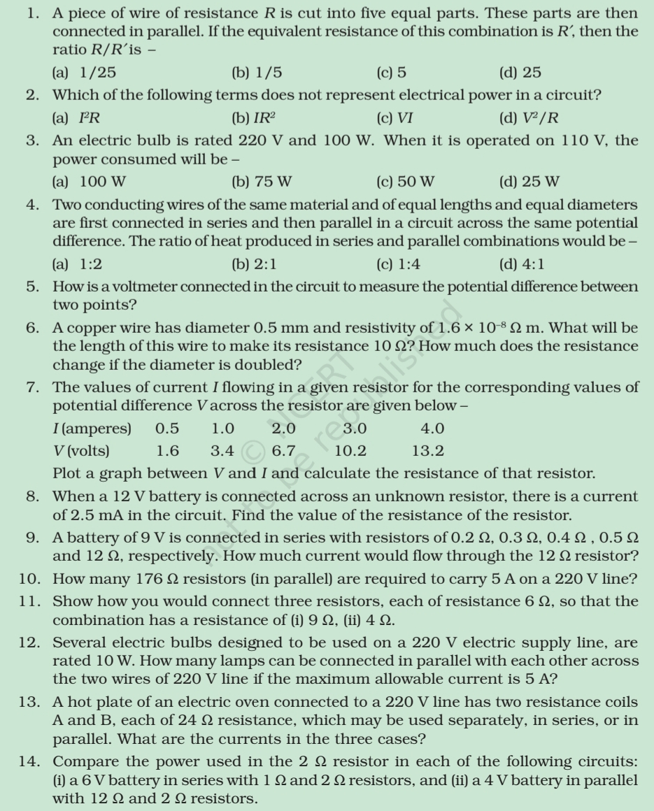
(continued on the next page…)
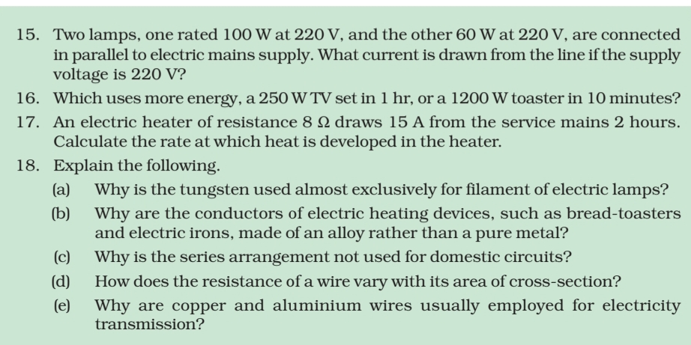
b)Note down the following points in your fair notebooks and learn them: -
